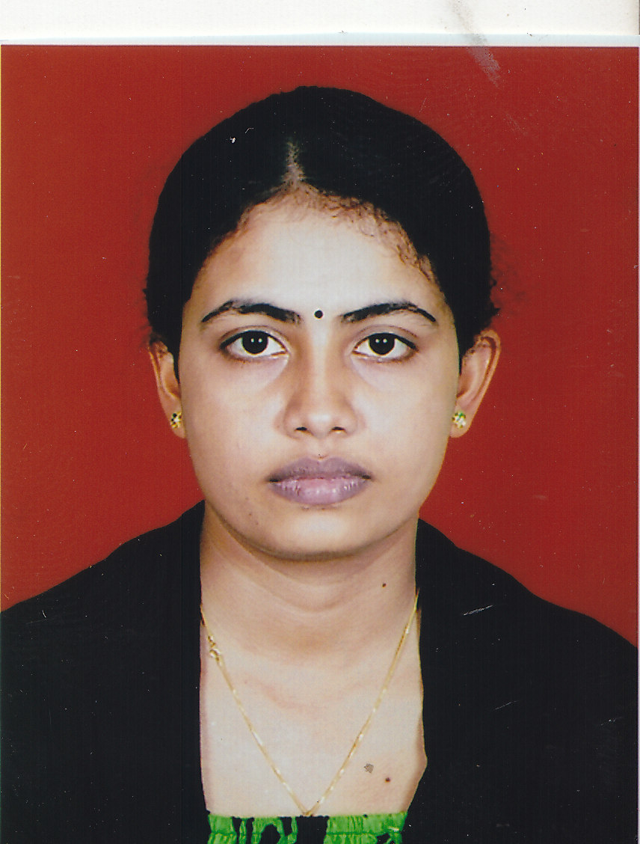 **THIBEKA SRISKANDARAJAH**

***No 50A,D Alleys Place,Dehiwala.***

***E-mail:THIBEKAS21@gmail.com***

***Tel: 0094767434243, 0094750434243.***



To enhance my skills by working in an organization that offers challenging environment and professional growth.

* Both Management and IT skills combined with a flexible attitude to work
* Have innovative ideas and ready to take the initiative in working alone or as part of a team
* Get on well with people at all levels and making good working relationships
* Adaptable and fast learner



* Successfully completed **general certificate of education ordinary level**
  + English : A
  + Social studies & history : A
  + Dancing : A
  + Health & Physical education : A
  + Saivism : A
  + Tamil : A
  + Business and accounts : B
  + Mathematics : B
  + Science : B
  + English Literature : S
* Successfully completed **General Certificate of Education Advance Level** in Science Stream.
  + Physics : S
  + Chemistry : S
  + Biology : S
  + English : S



* Following **HUMAN RESOURSE MANAGEMENT** in **ATI** Jaffna  
  (Successfully completed first year)   
  1ST SEMESTER RESULTS

|  |  |
| --- | --- |
| **SUBJECTS** | **RESULTS** |
| **STATICS** | **A** |
| **INFORMATION TECHNOLOGY** | **A** |
| **ENGLISH** | **A** |
| **FUNDERMENTALS OF MARKETING MANAGEMENT** | **A-** |
| **MANAGEMENT** | **B** |
| **BUSINESS ACCOUNTING** | **B** |

2nd SEMESTER RESULTS

|  |  |
| --- | --- |
| **SUBJECTS** | **RESULTS** |
| **HUMAN RESOURCE MANAGEMENT** | **A** |
| **INFORMATION TECHNOLOGY** | **A** |
| **MAKING PRESENTATION** | **A** |
| **ECONOMICS** | **A** |
| **BUSINESS LAW** | **A-** |
| **COST & ACCOUNTING** | **B** |

* Successfully completed **Diploma in Microsoft Office.**
* Following **CBF.(REGISTER NO:20055550)**



**LANGUAGE SKILL:**

**LANGUAGE UNDERSTAND SPEAK READ WRITE**

**ENGLISH** Very Good Very Good Very Good Very Good

**TAMIL** Very Good Very Good Very Good Very Good

**SINHALA**  Good Good Good Basic



* Working for results with dedication and determination.
* Positive, confident attitude and ability to work under pressure
* Have the perseverance to work till I get the desired result.
* Good communication skills, Fast learning ability and Good logical skills.



* Participated English competition every year and take places.
* Participated Tamil competition every year and take places.
* Gold Medalist of Oratory prepared competition.
* Editor of the Science Union.
* Vice President of the English Union.
* Captain of Athletic Team Rathy House.
* **Post Held in School:** Senior Prefect in Our School



**Surname :** SRISKANDARAJAH

**First name** : THIBEKA

**Date of birth** : 21st September 1991

**Gender :** Female

**NIC :** 917652821V

**Civil Status** : Single

**Nationality** : Sri Lankan

**School Attended :** J/Jaffna Hindu Ladies’ College.



Mrs. S.Subakaran

Senior lecturer,

Advanced Technological Institute,  
Dehiwalla.

Tel: +94718569962

Mr.A.Muralitharan

Manager,

Sampath Bank,

Jaffna.  
 Tel: +94777809664

I do hereby declare that foregoing particulars are true and accurate to the best of my knowledge.

.

**Thibeka Sriskandarajah**